1. Abstract

Date: 15 July 21
Project Title: Mask Management System

Project Abstract:

The issue of bio-medical waste during these covid times is something to be concerned about. During this corona pandemic, there is a huge increase in the masks waste. These masks are abandoned everywhere, on the streets, in public areas, in water channels. Disposal masks contain plastics which pollute water and can harm animals that eat them or get tangled in them. For this issue, 27-year old Binish Desai, known as the recycle man of India, came forward with a solution to convert biomedical waste especially single-use masks, head cover and non-woven PPE kit into bricks. To make people more familiar with this concept of bricks from waste we intend to make a management system. This web based management system will be created to provide a technical support to such project. According to this system, some trash cans are kept in residential areas where people will collect their masks. Further the trash collecting truck by Municipal Corporation will collect those in a special box kept in it for masks collection from all over the city. These boxes will be transported to the dumping yard which will be collected from there. After collection it will be further sent to the address provided by Dr. Binish Desai. Also, with such kind of project various information can be stored in the database such as, the login information, the amount of masks collected, etc. This project will provide required information to the user at every stage. From this project, we hope to provide a better technical support to the innovative project by Dr. Binish Desai.

2. Problem Statement

As mentioned in the introduction, Dr. Binish Desai is working on a project to convert reusable masks and PPE kits into bricks. A technical support is needed for such projects to maintain the database. Our project on an initial level needs to be created using free localized hosting. To maintain the record of received information is the need.

3. Motivation

The motivation for this entire Project was Abhi and Niyu’s Youtube video.

https://www.youtube.com/watch?v=uZiUP3Yg8Tk&feature=youtu.be

Being a CS Student it was always are dream for each and every member of our group to solve the problem, which people face in daily life so indeed it was and motivation for us.

When we saw the Abhi and Niyu’s Youtube video, we certainly thought that mainting database for collected masks, is quite a difficult task for that organization, so we decided to make a system will help to keep a record of it.

4. Objectives

- Creating technical support, software background and interface for mask collection task
- Fulfilling the requirement by SPPU for PBL subject eventually improving our coding skills.

5. System Architecture

A Definition of Web Application Architecture:

Web application architecture defines the interactions between applications, middleware systems and databases to ensure multiple applications can work together. When a user types in a URL and taps “Go,” the browser will find the Internet-facing computer the website lives on and requests that particular page.
The server then responds by sending files over to the browser. After that action, the browser executes those files to show the requested page to the user. Now, the user gets to interact with the website. Of course, all of these actions are executed within a matter of seconds. Otherwise, users wouldn’t bother with websites.
What’s important here is the code, which has been parsed by the browser. This very code may or may not have specific instructions telling the browser how to react to a wide swath of inputs. As a result, web application architecture includes all sub-components and external applications interchanges for an entire software application.
Of course, it is designed to function efficiently while meeting its specific needs and goals. Web application architecture is critical since the majority of global network traffic, and every single app and device uses web-based communication. It deals with scale, efficiency, robustness, and security.

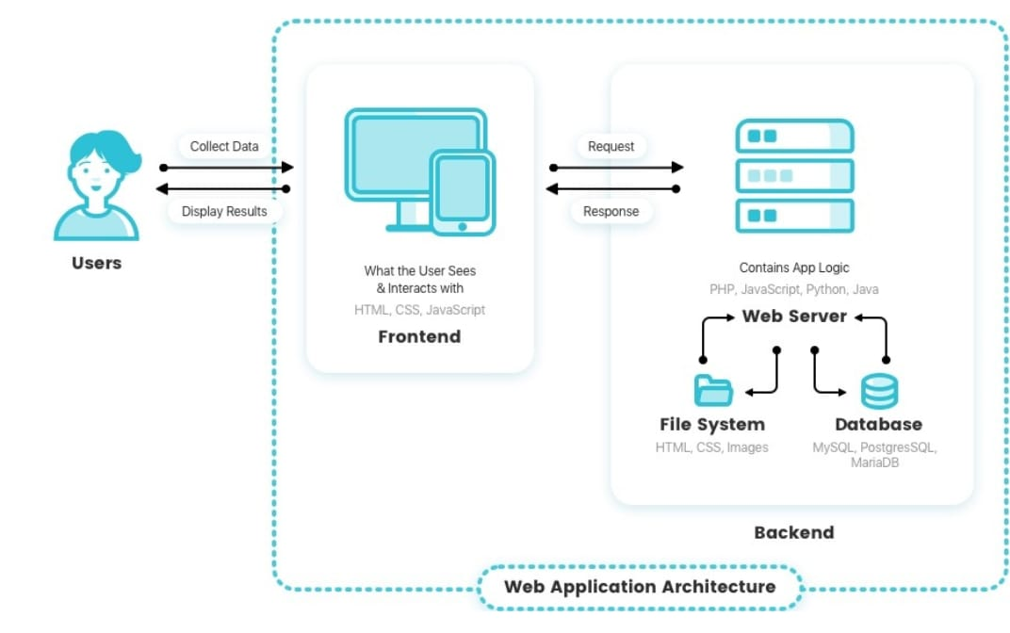

How Web Application Architecture Works

With web applications, you have the server vs. the client side. In essence, there are two programs running concurrently:
- The code which lives in the browser and responds to user input
- The code which lives on the server and responds to HTTP requests
When writing an app, it is up to the web developer to decide what the code on the server should do in relation to what the code on the browser should do. With server-side code, languages include:
- Ruby on Rails
- PHP
- C#
- Java
- Python
- Java Script
In fact, any code that can respond to HTTP requests has the capability to run on a server. Here are a few other attributes of server-side code:
- Is never seen by the user (except within a rare malfunction)
- Stores data such as user profiles, tweets, pages, etc…
- Creates the page the user requested
With client-side code, languages used include:
- CSS
- Java Script
- HTML
These are then parsed by the user’s browser. Moreover, client-side code can be seen and edited by the user. Plus, it has to communicate only through HTTP requests and cannot read files off of a server directly. Furthermore, it reacts to user input.

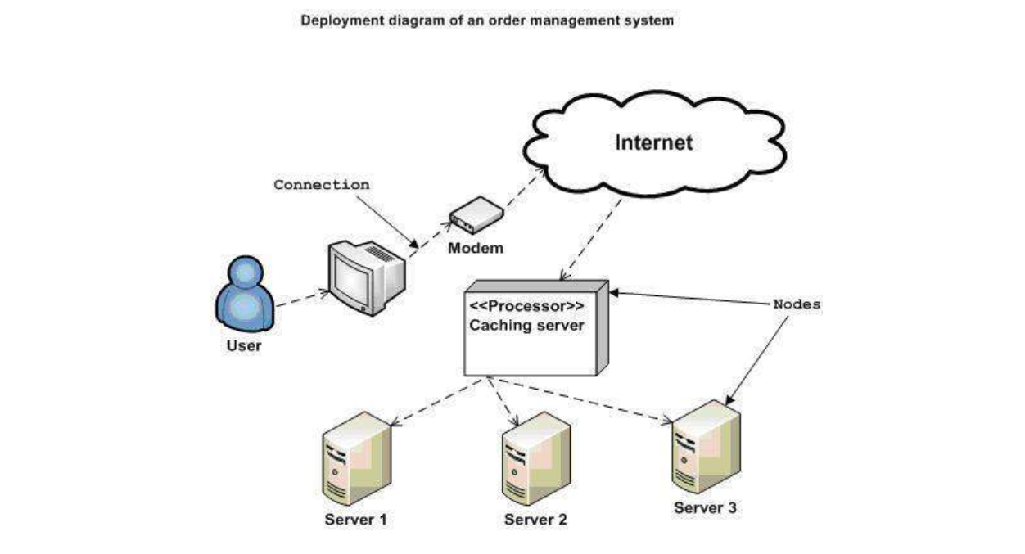

6. Software Requirement Specification (SRS)

- INTRODUCTION:
1.1 Purpose:
The purpose to build a mask management system is to create a software background and interface for the mask collection task.
1.2 Project Scope:
We intend to create a database system which will support Dr. Binish Desai’s innovative idea of converting masks to bricks. This will help users in managing the mask waste and will eventually reduce the biomedical waste in the surroundings.

- OVERALL DESCRIPTION:

  - Objectives:
- Creating technical support, software background and user-friendly interface for mask collection task.
- Fulfilling the requirement by SPPU for PBL subject.

  - Product Perspective and Details:
The Mask Management System is a database-oriented system with great initiative of masks collection. Through this system the user can donate the used masks in the mask bins provided in their locality. These mask bins will be collected by the municipalities and will be picked up by the receiver. All the data of this throughout process will be stored on our system.

- SYSTEM REQUIREMENTS:

  - Distributed database:
Distributed database implies that a single application should be able to operate transparently on data that is spread across a variety of different databases and connected by a communication network as shown in below figure.

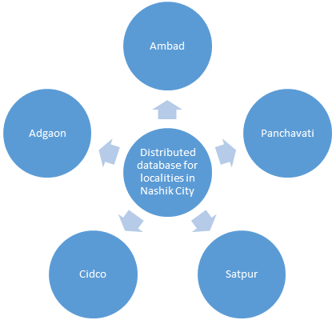

Client server system:
The term client/server refers primarily to an architecture or logical division of responsibilities, the client is the application (also known as the front-end), and the server is the DBMS (also known as the back-end). All the data resides at the server site. Application executes at the client site. Mask Management System is client server system.

INTERFACE REQUIREMENTS:

Software Interfaces:
Front end software: HTML, JavaScript, CSS
Back-end software: MySQL, PHP

Hardware Interfaces:
Laptop, Windows operating system.

Communication Interfaces:
This project supports all types of web browsers.

FUNCTIONAL REQUIREMENTS:

Safety Requirements:

If there is extensive damage to a wide portion of the database due to any failure, such as a disk crash, the recovery method restores a past copy of the database that was backed up to archival storage and reconstructs a more current state by reapplying or redoing the operations up to the time of failure.

Security Requirements:

Security systems need database storage just like many other applications. However, the special requirements of the security market mean that vendors must choose their database very carefully.

NON-FUNCTIONAL REQUIREMENTS:

Availability: Bins will be available in that particular locality to donate masks for users.

Correctness: The bins will eventually reach the receiver correctly for further processing.

Maintainability: The database system should maintain correct record of the bins collected.

Usability: The system should satisfy maximum no. of user needs.

Performance: The system should work fast and give its best performance.

DESIGN CONSTRAINTS:

Start page design with a container that will hold all your page content.

Design flexibly. Account for the fact that viewers will stretch and distort your designs. If you design with flexibility for example, taking into account that text will expand as a user zooms in on your page you can create page designs that bend but don’t break when they’re viewed in different environments.

Create unique page design or content for full-sized and mobile sites.

APPENDICES:

References:
IEEE Reference pages on Hospital Management System: https://ieeexplore.ieee.org/document/7546371
Abhi and Niyu Youtube Video:
https://youtu.be/uZiUP3Yg8Tk

7. System Flow (Work Flow)

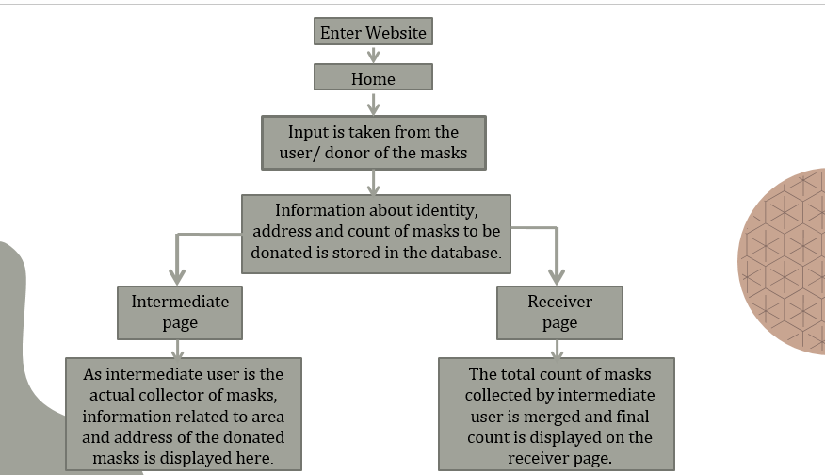

Data Flow Diagrams
DFD LEVEL 0
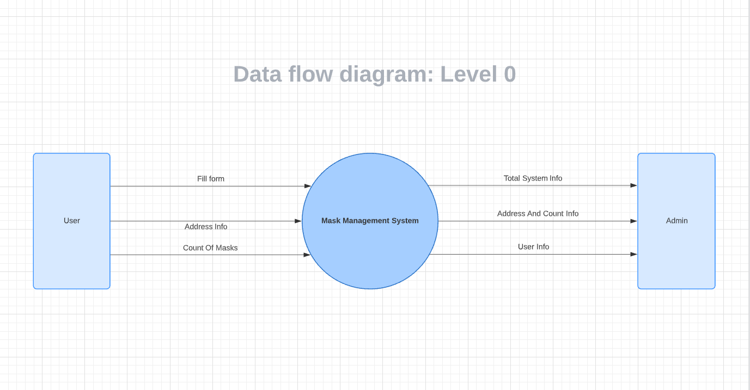

DFD LEVEL 1
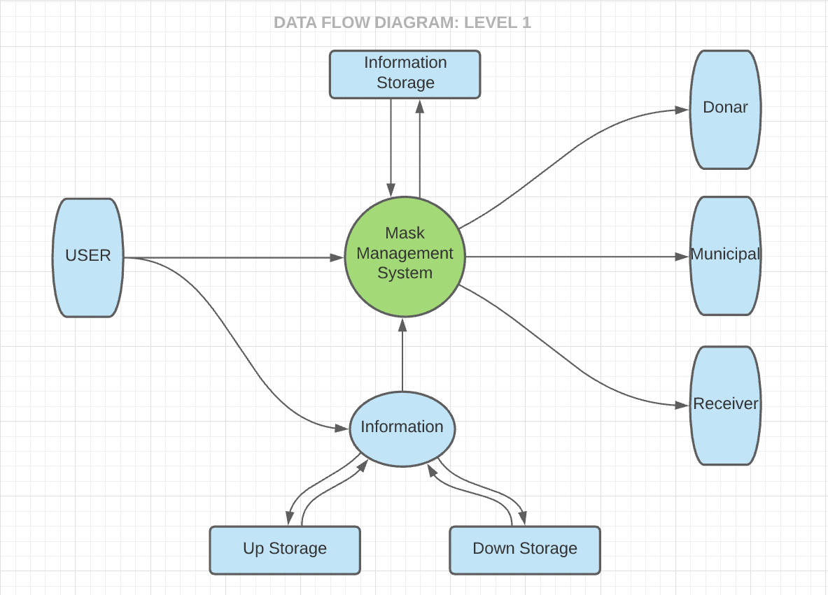

DFD Level 2
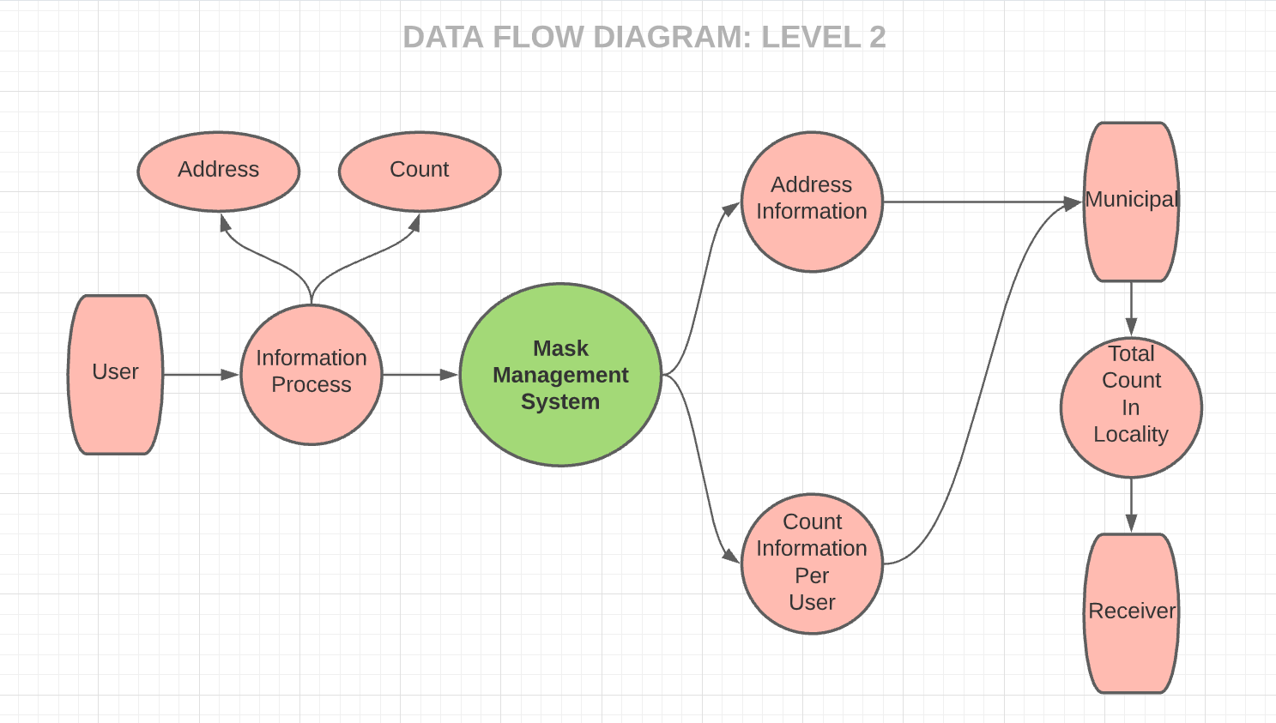

8. Methodology & Proposed System Block Diagram

Waterfall is the most conventional software development methodology. In fact, it has been one of the most popular approaches for web development projects for several decades due to its plan-driven approach.
The Waterfall approach requires a lot of structure and documentation. The process is divided into several stages that form a sequence:
- Analysis
- Design
- Implementation
- Testing
- Maintenance
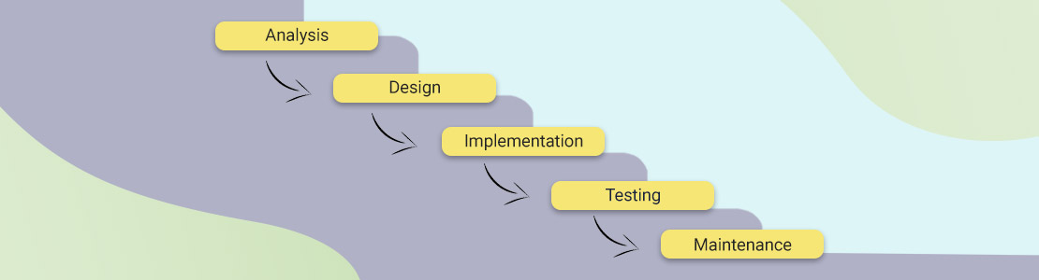

9. UML Diagrams

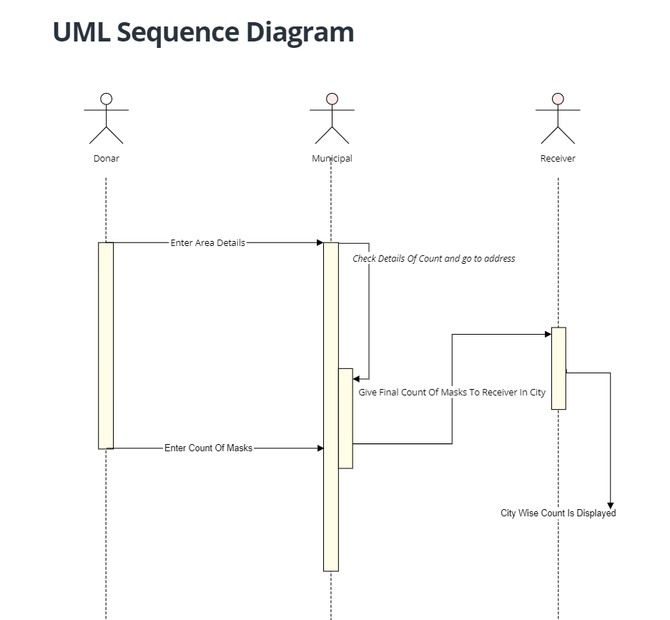

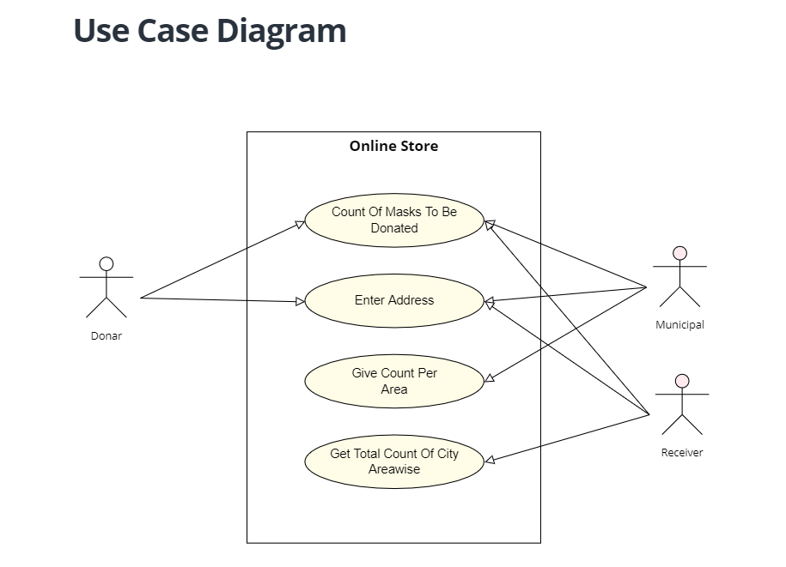
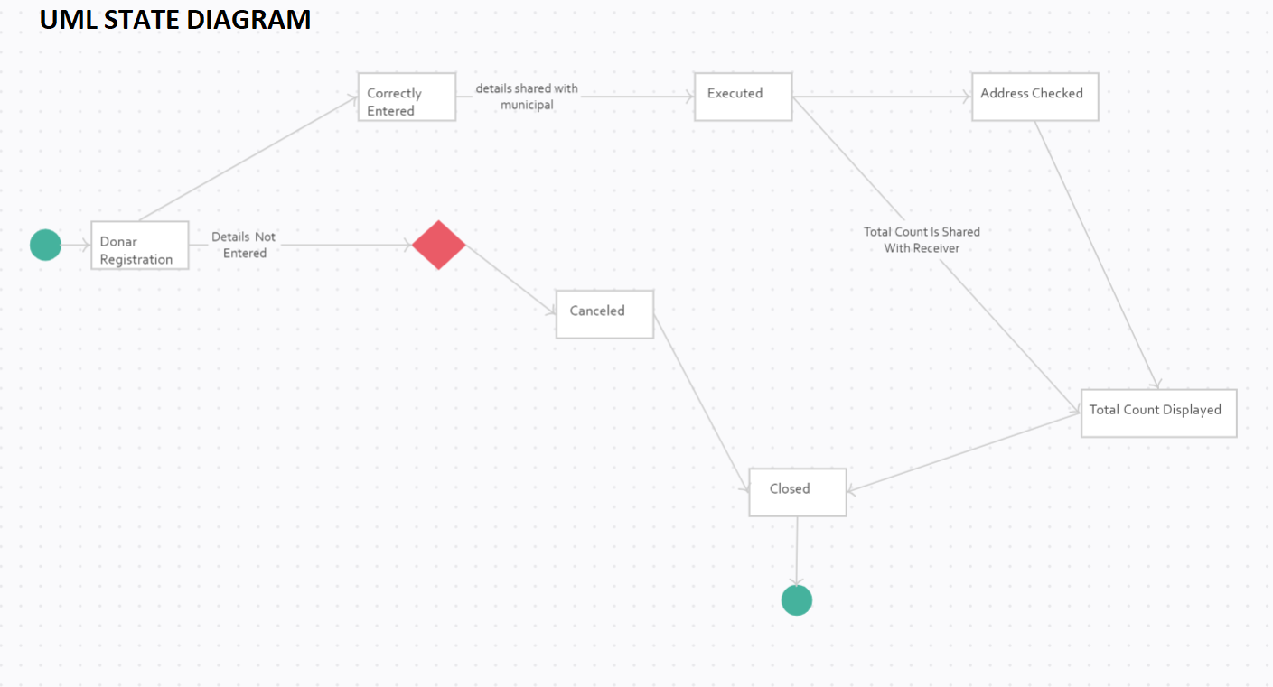

10. Software and Hardware Requirement

- Sublime Text is a shareware cross-platform source code editor with a Python application programming interface (API). It natively supports many programming languages and markup languages, and functions can be added by users with plugins, typically community-built and maintained under free-software licenses

- XAMPP is a software distribution which provides the Apache web server, MySQL database (actually MariaDB), Php and Perl (as command-line executables and Apache modules) all in one package. It is available for Windows, MAC and Linux systems. No configuration is necessary to integrate Php with MySQL

- The only advantage of such hosting service is their cost effectiveness. They are absolutely free of cost and require not any paid subscription. However, the exact plan and policy may vary from one hosting service provider to another

11. Implementation

The software implementation stage involves the transformation of the software technical data package (TDP) into one or more fabricated, integrated, and tested software configuration items that are ready for software acceptance testing.

We have implemented the entire Project on Free Hosting awardspace.com.
Will further updates it will be used for actual data gathering and handling process.

12.Result and Test Cases

- The website is working partially good facing some issues related to
DDMS and responsiveness.
- All features are active.
- Website is displayed in both mobile and desktop mode.
- The buttons on navigation bar loads the corresponding page correctly.

13. Challenges Faced

1) The major challenge we faced was, we were not familiar with web based languages.
2) Also we were not familiar with the Database.
3) Also, it was quite a difficult task for group leader to communicate with each member personally as we haven’t met in person yet.
4) We were only able to communicate virtually.

14. Conclusion and Future Scope

If conducted on a large scale our project has a high scope in reducing the mask waste. This certainly impacts not one but many factors, leading to a clean and green environment. It's a simple initiative to take up for everyone, throw it but in the right place. It needs little advertising and is possibly the easiest of methods to terminate mask waste. Not only it can reduce the mask waste, but promote people in participating in healthy activities.

15. References

1] Abhi and Niyu Youtube Channel

(https://www.youtube.com/watch?v=uZiUP3Yg8Tk)

2] IEEE‘s DBMS. (https://ieeexplore.ieee.org/Xplore/home.jsp)

Reference Papers:

[1] L. Liu and H. Miao, "A specification based approach to testing polymorphic attributes," in Formal Methods and Software Engineering: Proc. of the 6th Int. Conf. on Formal Engineering Methods, ICFEM 2004, Seattle, WA, USA, November 8-12, 2004, J. Davies, W. Schulte, M. Barnett, Eds. Berlin: Springer, 2004. pp. 306-19.

[2] An intelligent hospital information management system was developed to assist the patient at the front desk of a hospital. The patient will be able to learn about the doctors, appointment times, relevant departments, laboratory tests and the specific medicine about his/her medical situation. System will provide an intelligent front desk information service for the patients at the hospital entrance. It will also provide software assistance for the doctors to diagnose easily and rapidly by using the program's decision mechanism.
Published in: 2015 International Conference on Computational Intelligence and Communication Networks (CICN)
Date of Conference: 12-14 Dec. 2015
Date Added to IEEE Xplore: 18 August 2016
ISBN Information:
Electronic ISSN: 2472-7555
INSPEC Accession Number: 16248106
DOI: 10.1109/CICN.2015.305
Publisher: IEEE
Conference Location: Jabalpur, India

[3] This paper describes the design and implementation of a special-purpose distributed data management system. The design and implementation were parts of a study to evaluate the database management needs of software-defined logical subnetworks. The paper describes the authorization model used to define logical subnetworks and the related subnetwork management transactions. The definition of the subnetworks and their service capabilities are stored in a distributed database. The distributed database architecture and the implemented software architecture are described. The requirement to design and implement within a specific time frame has kept the design simple, but the nature of the application dictated that we consider many aspects of the more general distributed data-management problem. The database management issues that are addressed in this paper, in the context of transaction processing, include multicopy updates, concurrency control, and crash recovery. A version of the primary node concept for multicopy updates was adopted. Data inconsistencies, created by premature termination of transaction processing (e.g., system crash), are detected and removed by the software.
Published in: The Bell System Technical Journal ( Volume: 61, Issue: 9, Nov. 1982)
Page(s): 2459 - 2474
Date of Publication: Nov. 1982
Print ISSN: 0005-8580

